**MEDICAID MESSAGES**

**Key Statistics**

* Medicaid makes it possible for 1 in 5 Americans to access affordable medical coverage
* 63% of nursing home residents have Medicaid
* 49% of American children have Medicaid
* 44% of non-elderly disabled Americans have Medicaid
* 41% of all births in America are covered by Medicaid

**Key Messages: The Value of Medicaid**

* Medicaid is a public health insurance program for children, pregnant people, seniors, people with disabilities, and adults with low incomes. It allows them to get the health care they need to get and stay healthy.
* When more people have access to affordable coverage, they are able to catch and treat ailments early instead of waiting until they need emergency care. Medicaid allows people to get regular checkups to stay healthy, see a doctor when they’re sick, and access the medications they need.
* For workers who don’t get health insurance through their job and can’t afford private insurance, or for those who were just laid off and who live in Medicaid expansion states, Medicaid provides access to affordable health care for themselves and their families.
* Most people who need help affording health coverage DO work. Work requirement policies being proposed do not actually help people get healthy enough to stay employed. A person needs to be well to look for and keep a job. Punishing people who have lost a job—or even a few shifts at their job— by taking away their access to medications and medical care will only make them sicker and less able to work in the future. The vast majority of people who get their health insurance through Medicaid are caregivers, working or attending school, or have an illness or injury that legitimately prevents them from working.

**Sample Social Media Posts**

For more content visit: <https://www.chausa.org/advocacy/medicaid/social-media-toolkit>

*No one should choose between getting the health care they need and paying for rent, gas, or groceries. Medicaid provides peace of mind to individuals and families and allows them to get the care they need without the fear of catastrophic bills and medical debt. #MedicaidPossible*

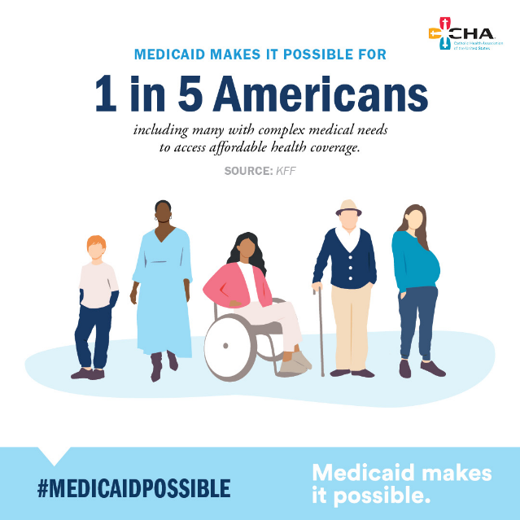

*For far too many, the cost of health care is out of reach, leading them to delay needed care or avoid seeking care at all. Medicaid removes barriers to accessing the affordable health care people need. #MedicaidPossible*

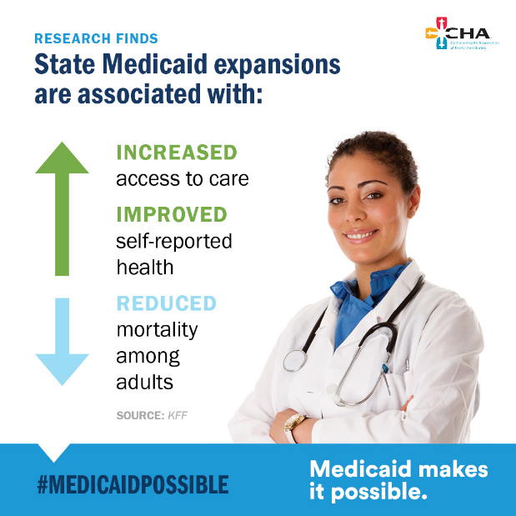

*Proposals to institute work requirements for Medicaid are intended to solve a problem that doesn’t exist. It’s more important to focus on how we can keep our workforce healthy and employed, especially for those who suffer from disabilities or chronic conditions. #MedicaidPossible*

**Template Op-ed**

**The Moral Imperative to Keep Medicaid Healthy**

By [INSERT NAME AND TITLE OF AUTHOR]

*Keep the word count to fewer than 600 words*

For 60 years, Medicaid has provided essential health coverage for millions of Americans, ensuring that low-income families, seniors, people with disabilities, and children receive the care they need. Yet, policymakers in Washington are considering hundreds of billions of dollars in cuts to this essential program. Such a deeply flawed proposal must be rejected—not just because of its devastating impact on public health but because it ignores a fundamental moral truth: healthcare is not a privilege; it is a human right. As a woman of faith who has devoted her life to caring for the sick, the poor, and the most vulnerable among us, I stand firmly in support of preserving and strengthening Medicaid for those who need it most.

As we seek to address the challenges in our health care system, dismantling Medicaid—one of the strongest safety nets for our nation's most vulnerable—is not reform; it is reckless. This issue is especially urgent for those of us serving in faith-based health care. The Judeo-Christian tradition teaches that each person is created in the image of God and that human dignity must be protected.

Health care is not a privilege for the fortunate—it is a fundamental human right. Jesus' teachings affirm that every person is made in the image of God and that we have a moral obligation to uphold the dignity of each human life. Our faith as Christians compels us to recognize the uniqueness and worth of every human life, and health care is essential to human flourishing. Dismantling Medicaid would turn our backs on this sacred responsibility. As Pope Francis affirmed, “Health is not a luxury; it is for all.”

Weakening Medicaid would undermine these values and risk leaving millions without access to essential health coverage. As Catholics, we believe in the value of work and its contribution to providing a person dignity. However, Medicaid work reporting requirements have clearly shown to create artificial barriers to care, generating paperwork and bureaucracy while doing little to support people looking for work. These requirements also fail to recognize that most people on Medicaid already work and ignore the realities of low-wage work, caregiving responsibilities, and health limitations.

Medicaid expansion has been linked to improved financial well-being for low-income families, reduced medical debt, and helping people stay financially stable. A healthier population leads to a stronger workforce and a more productive economy—proof that Medicaid is not just a safety net but a smart investment in our nation's future. This is why 76% of Americans view this essential health coverage favorably.

At [INSERT NAME OF YOUR MINISTRY OR CONGREGATION], our mission was founded on the call to serve all, especially those who are poor and marginalized. Medicaid is one of the most effective tools we have to fulfill that mission. Weakening it would betray the values we hold dear.

We urge Congress and the Administration to affirm this commitment by protecting and strengthening Medicaid, not dismantling it.

The health of our people reflects our nation's moral priorities. If we value dignity, justice, and compassion, then we must protect Medicaid—because when Medicaid is strong, America is strong.

###